Evaluating the impact of an enhanced triage process on the performance and diagnostic yield of oesophageal physiology studies post COVID-19

# Demographics

|  | | Era | | AGIP Traffic light code | | |
| --- | --- | --- | --- | --- | --- | --- |
|  | | Pre-ETP   N=135 | Post-ETP   N=99 | Red   N=29 | Amber   N=13 | Green   N=57 |
| Age | Mean (SD) | 50.9 (15.04) | 49.5 (16.56) | 49.3 (20.5) | 49.3 (15.54) | 49.5 (14.76) |
| Gender | Female | 76 (56.3%) | 71 (71.7%) | 22 (75.9%) | 10 (76.9%) | 39 (68.4%) |
| Male | 59 (43.7%) | 28 (28.3%) | 7 (24.1%) | 3 (23.1%) | 18 (31.6%) |
| Routine or Urgent | Routine | 115 (85.2%) | 78 (78.8%) | 24 (82.8%) | 8 (61.5%) | 46 (80.7%) |
| Urgent | 20 (14.8%) | 21 (21.2%) | 5 (17.2%) | 5 (38.5%) | 11 (19.3%) |
| Swallowing and Reflux Indications | Both | 35 (25.9%) | 16 (16.2%) | 3 (10.3%) | 9 (69.2%) | 4 (7%) |
| Swallowing Only | 23 (17%) | 31 (31.3%) | 26 (89.7%) | 4 (30.8%) | 1 (1.8%) |
| Reflux Only | 76 (56.3%) | 52 (52.5%) | 0 | 0 | 52 (91.2%) |
| Neither | 1 (0.7%) | 0 |  |  |  |
| Finding | Major | 12 (8.9%) | 17 (17.2%) | 10 (34.5%) | 5 (38.5%) | 2 (3.5%) |
| Minor | 53 (39.3%) | 34 (34.3%) | 8 (27.6%) | 2 (15.4%) | 24 (42.1%) |
| Normal | 67 (49.6%) | 48 (48.5%) | 11 (37.9%) | 6 (46.2%) | 31 (54.4%) |
| Not Done | 3 (2.2%) | 0 |  |  |  |
| Acid Reflux Finding | Severe | 18 (13.3%) | 12 (12.1%) | 1 (3.4%) | 3 (23.1%) | 8 (14%) |
| Moderate | 9 (6.7%) | 4 (4%) | 1 (3.4%) | 1 (7.7%) | 2 (3.5%) |
| Mild | 18 (13.3%) | 9 (9.1%) | 1 (3.4%) | 0 | 8 (14%) |
| Normal | 67 (49.6%) | 38 (38.4%) | 6 (20.7%) | 5 (38.5%) | 27 (47.4%) |
| Not Done | 23 (17%) | 36 (36.4%) | 20 (69%) | 4 (30.8%) | 12 (21.1%) |
| AGIP traffic light code | Red |  | 29 (29.3%) |  |  |  |
| Amber |  | 13 (13.1%) |  |  |  |
| Green |  | 57 (57.6%) |  |  |  |

# Referrals

|  | Pre-ETP   N=209 | Post-ETP   N=176 |
| --- | --- | --- |
| Attended, had test | 135 (64.6%) | 99 (56.2%) |
| Attended, unable to tolerate | 39 (18.7%) | 22 (12.5%) |
| Declined | 16 (7.7%) | 50 (28.4%) |
| No Show | 19 (9.1%) | 5 (2.8%) |

In the Post-Covid era, there were fewer missed appointments (difference=-6.2%pts, reduction=68.8%, p=0.021).

# Findings for AGIP Traffic Light

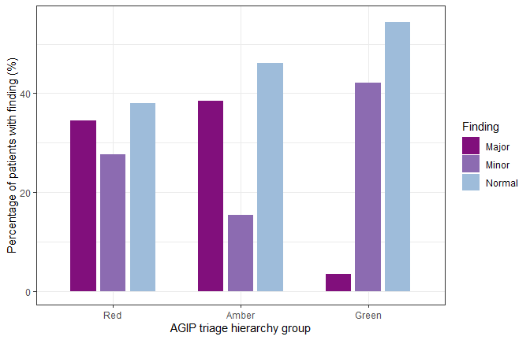

A core finding here is that significantly more people triaged as Red go on to have major findings (JT test: p=0.012).

# Time to be seen

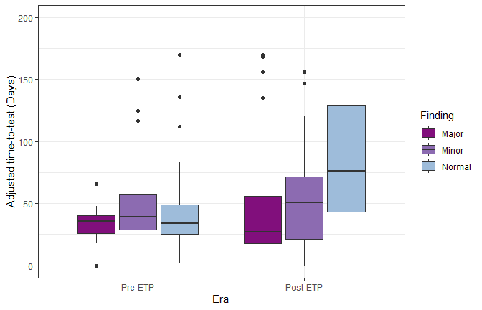

From the above plot, we can quite clearly see that the new triage system means that those with Major findings are on the whole seen quicker that those without. Pre-ETP, there was very little difference between the time to get seen by finding but now with the massive backlog the major case are being seen sooner. We computed an ANOVA model with time to test (Pre-ETP: Referral to test, Post-ETP: Referral or service resumption (whichever is later) to test) and independent variables of era and finding (with interaction). There was a significant interaction between era and finding ($F_{2,225}$ =5.67,p=0.004). As a sensitivity analysis, ANOVA was performed on the data removing all outliers ($F_{2,207}$ =5.67,p<0.001) and all patients who were not seen within 6 months ($F_{2,223}$ =5.67, p=0.008).

## Acid reflux

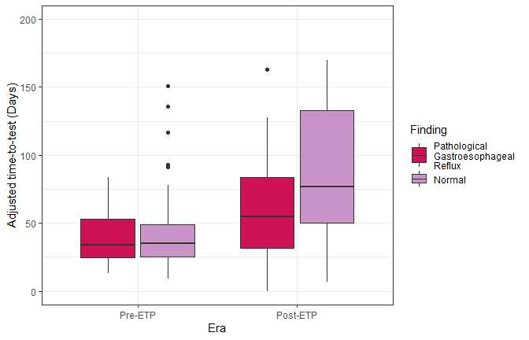

It can be seen here that there is no significant interaction between AR finding and era ($F_{1,151}$ =2.55,p=0.11). These include only patients that had the test done and had a reflux indication on referral.